Graph 1: Percentage of missed calls with each PDSA cycle

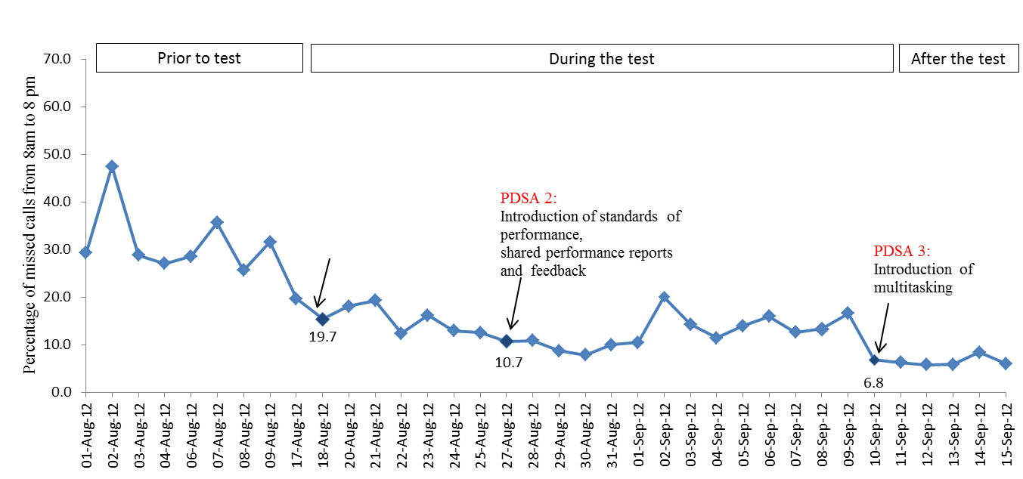
PDSA 1:
Introduction to log-in feature

Graph 2: Percentage of missed calls for each month (June 2012 – June 2015)
