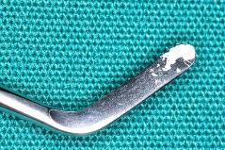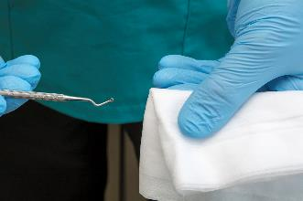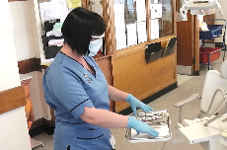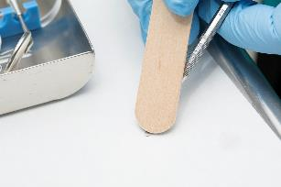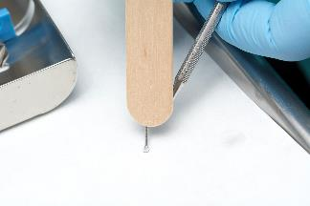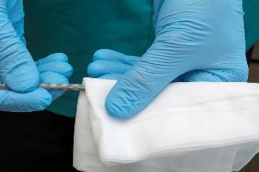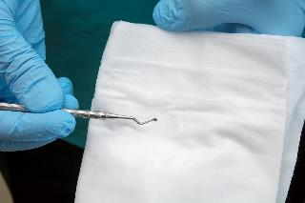

**MANUAL CLEANING of INSTRUMENTS**

Manually clean our instruments before returning them to the trolley

**IT IS YOUR OWN RESPONSIBILITY TO CARRY THIS OUT.**

**WHAT CAN WE DO?**

* Cross infection risk
* Compromised patient care, and increased costs

**Wipe again with a detergent wipe, and re-inspect**

* Kits are being returned to the Dental Hospital with cement still contaminating instruments.
* CSSD do not carry out manual cleaning.

**WHY?**

**THE PROBLEM**

**If cement cannot be removed by this method, dispose of the instrument in a sharps bin**

**If found, first use a detergent wipe, ensuring the wiping action is in one direction only, away from any part likely to pose a risk of a stick injury**

**If cement still present, then hold the instrument so the tip is in contact with the top of the bracket table, then use a wooden spatula to remove the cement**

**Inspect all instruments in your kit for contamination after use.**

**Ensure you are wearing your personal protective equipment (glasses, mask and gloves)**