Background research
Smoking Kills – A White Paper on Tobacco
- Over 120,000 people are killed a year because they smoke.
- Halve of all who continue to smoke for most of their lives die of the habit.
- Those who smoke regularly and die of a smoking-related disease lose an average 16 years from their life expectancy
- For every 1000 20-year-old smokers, one will be murdered, six will die in motor accidents, 250 will die in middle age from smoking, and 250 will die in older age from smoking.
- Smoking causes 84% of deaths from lung cancer, and 83% of deaths from chronic obstructive lung disease.
- Smoking causes 3 out of 10 cancer deaths.
- Smoking causes 1 out of every 7 deaths from heart disease.
- Prevalence of smoking in 1998 – 28%.
- Prevalence of smoking in 2012 – 20%.¹

Smoking cessation in secondary care: acute, maternity and mental health services.²
- The benefits of stopping smoking are well known…extensive evidence on effective and cost-effective stop smoking interventions.
- Tobacco smoking remains the single greatest cause of preventable illness and premature death in England. Cancer, cardiovascular disease, respiratory diseases, age-related macular degeneration, gastric ulcers, impotence, osteoporosis, increased risk of miscarriage, premature birth and low birthweight in pregnancy. Lower survival rates, delayed wound healing, increased infections, prolonged hospital stays and repeated admissions after surgery.
- People are required by law to abstain from smoking inside enclosed or substantially enclosed buildings. Most NHS secondary care settings also apply smokefree policies to their grounds.
- 65% of smokers want to quit their habit, but are unable to do so. ³
- Deliver support to the person who has been referred at the earliest possible opportunity. For outpatients (including pre-operative assessments) this should be immediate, and for inpatients usually within 1 working day.
- Recommend and offer NRT products (a combination of transdermal patches with a short-acting product such as an inhalator, gum, lozenges or spray) to all people who smoke OR varenicline or bupropion as sole therapy as appropriate.
- When people are discharged from hospital ensure they have sufficient stop smoking pharmacotherapy to last until their next contact with a stop smoking service.
- Ensure all frontline healthcare staff are trained to deliver stop smoking interventions.
- Ensure online training can be completed and updated annually as part of NHS mandatory training.
- Costs:
  - Treating smoking-related illnesses cost the NHS an estimated £2.7 billion in 2006.
Helping people admitted to secondary care to abstain temporarily if they do not want to stop smoking completely:
- For people admitted to secondary care services who are only prepared to abstain temporarily, encourage use of combination NRT to help reduce cravings to smoke during their stay. Provide information about the different types of nicotine replacement therapy (NRT) and how to use them. Where possible, supply or prescribe NRT immediately.

Cost-effectiveness of pharmacotherapy for smoking cessation⁴
- In 2002, the cost per lifetime quitter was put between £1,173 and £2,288.
- The ICER of NRT (compared to GP advice) ranged between £494 and £3,554 per QALY.
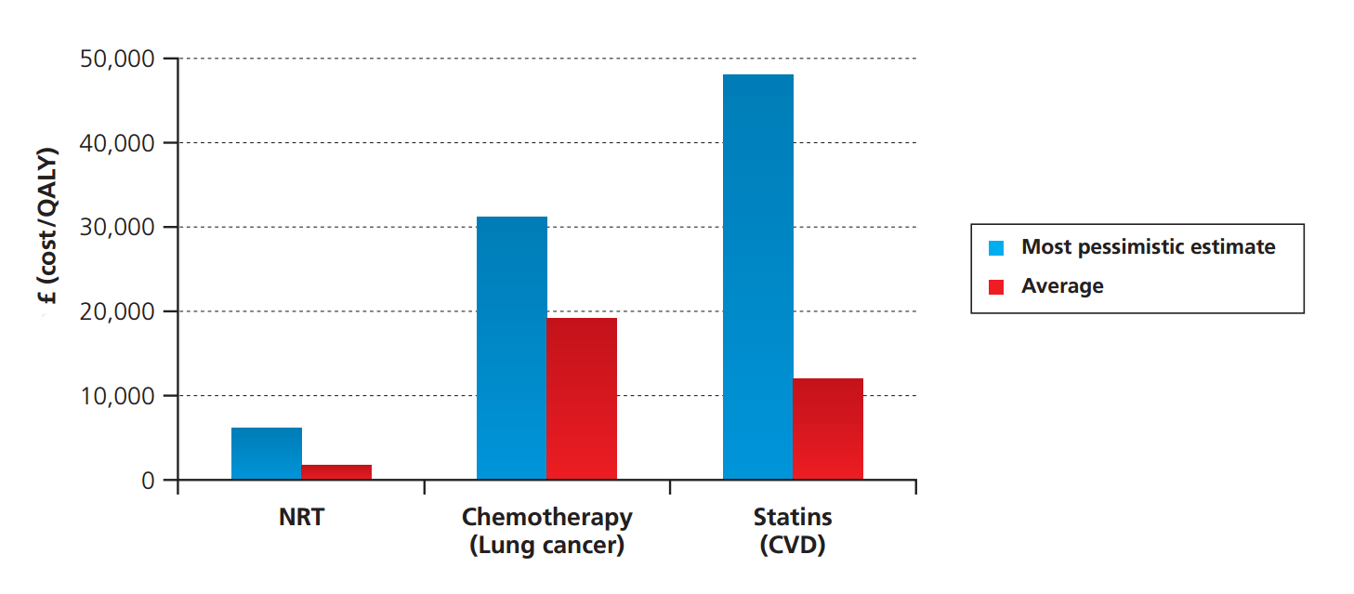

References

1. Department of Health. A White Paper on Tobacco. London: London: The Stationery Office; 1998.

2. Action on smoking and health. Smoking statistics - Who smokes and how much [Internet]. 2014 [cited 5 September 2014]. Available from: http://ash.org.uk/files/documents/ASH_106.pdf

3. Nice.org.uk. Smoking cessation in secondary care: acute, maternity and mental health services | Guidance and guidelines | NICE [Internet]. 2013 [cited 15 September 2015]. Available from: http://www.nice.org.uk/Guidance/PH48

4. Robinson S, Bugler C. Smoking and drinking among adults, 2008 [Internet]. 1st ed. Newport: Crown; 2010 [cited 8 September 2014]. Available from: http://www.ons.gov.uk/ons/rel/ghs/general-lifestyle-survey/2008-report/smoking-and-drinking-among-adults--2008.pdf

5. Shahab L. Cost-effectiveness of pharmacotherapy for smoking cessation [Internet]. 1st ed. London; 2012 [cited 14 September 2014]. Available from: http://www.ncsct.co.uk/usr/pub/B7_Cost-effectiveness_pharmacotherapy.pdf

