Figure 1 – Feedback from A&E Staff following the introduction of the pilot study

Figure 1: Clearly demonstrates a positive response to the introduction of the pilot system.

Figure 2: Graph comparing the number of times key pieces of information were recorded pre & post intervention.
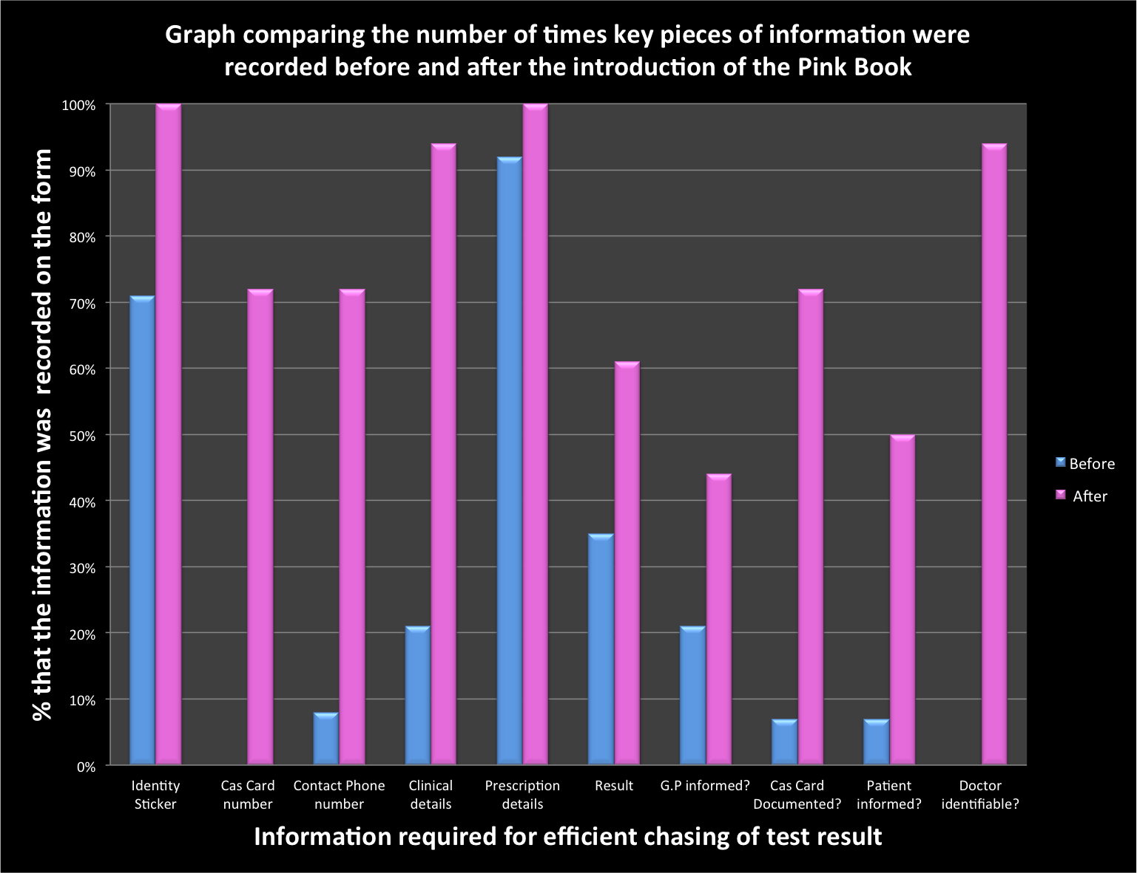
Figure 2: Clearly demonstrates the greater quantity and quality of information recorded in all 10 areas of assessment once the Pink Book was in introduced
Example of Pink book proforma

REPORT ALL POSITIVE RESULTS TO GP
DOCUMENT ALL POSITIVE RESULTS IN CAS CARD

Patient Details: (Sticky)  Name:  DOB:  Hosp Number: | GP Phone Number:  Cas Card Number:
Clinical details:

Sample taken:

Prescription given:
Signature:
Admitted / discharged? Name:
Date:
Results:

Action taken:

GP informed: Y / N Parents informed: Y / N  Cas card documented: Y / N  Completed: |  | Signature:  Name:  Date:

