Supplementary file Methods:
Table 1: Baseline Pancreas post-operative morbidity 2010

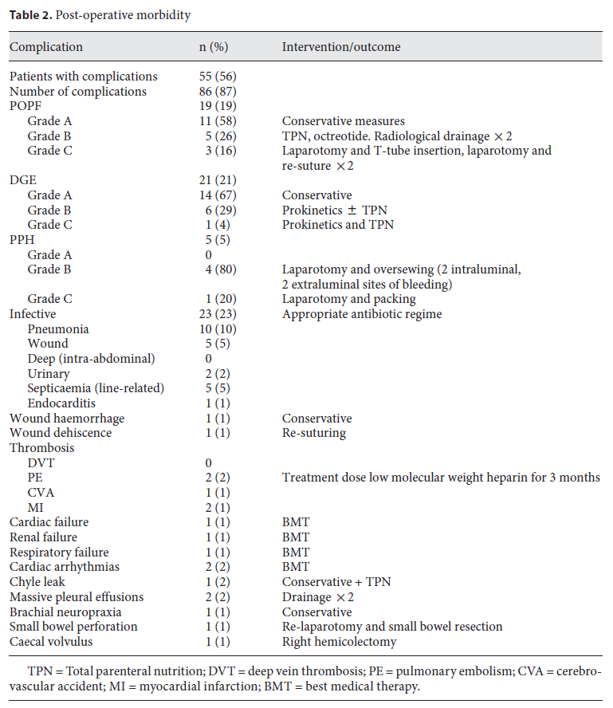

(Permission to reprint above given by publisher: S. Karger AG Basel (2))

Figure 1: Pancreas post-operative complications according to the ISGPS definitions (2)
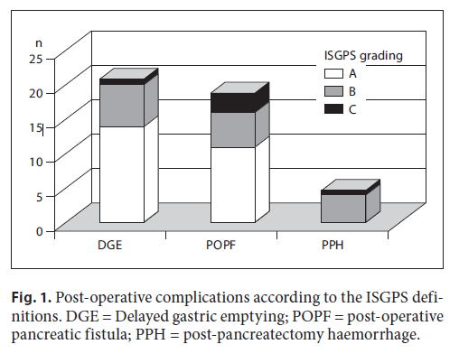

(Permission to reprint above given by publisher: S. Karger AG Basel (2))

Supplementary file: The HPB QIP Proforma
Patient Demographics:
Name

Unit Number

DOB

Consultant

Operative Details:
Operation

Date
Time
Operating surgeon

Elective / Emergency

Complication Codes: (Please note date diagnosis made if applicable)
Code | Complication | Grade | Justified | Error | Action Plan
A | Pancreatic fistula
B | Delayed gastric emptying
C | Post pancreatectomy  Haemorrhage
D | Bile leak
E | Liver failure
F | Post hepatectomy haemorrhage
G | Cardiac
H | Pulmonary
I | DVT/PE
J | Wound
K | Other
L | Readmission within 30 days
M | Death
N | Unplanned return to theatre

A: Pancreatic fistula (ISGPF)
ISGPF Definition: “Output via an operatively placed drain (or a subsequently placed percutaneous drain) of any measurable volume of drain fluid on or after postoperative d 3, with an amylase content greater than 3 times the upper normal serum value”

Grade A  “Transient  fistula” | No clinical  impact | No peri-pancreatic collections on CT scan; little/no change in management  High drain amylase but nil else needed | Clinically well; no sepsis; no prolongation of hospital stay; slow removal of operatively placed drains
Grade B | Clinical impact | Peri-pancreatic drains in place or repositioned to drain collections; Change in management is required | Clinically fairly well; degree of infection requiring specific treatment; prolongation of hospital stay; patients often discharged with drains in situ and observed in outpatient setting
Grade C | Severe  clinical impact | Worrisome peri-pancreatic collections that require percutaneous drains; major change in management usually in ICU setting; possible re-surgery to salvage a difficult situation  (completion pancreatectomy etc) | Clinically unwell; associated sepsis requiring aggressive antibiotics, octreotide and other intensive care support; major prolongation of hospital stay; associated complications

B: Delayed gastric emptying (ISGPF)

Grade A | Need for NGT intubation for 4 d or NGT reinsertion  after postoperative day (POD) 3, or inability to tolerate a solid diet by POD 7.
Grade B | Need for NGT intubation for 8 d or NGT reinsertion  after POD 7, or inability to tolerate a solid diet by POD 14.
Grade C | Need for NGT intubation for 15 d or NGT reinsertion  After POD 15

C: Post Pancreatectomy haemorrhage (ISGPF)

 | Onset, location, presentation and severity | Condition | Diagnosis | Treatment
Grade A | Early, intra or extraluminal mild | Well | Observation, blood count, USG and, if necessary CT | No
Grade B | Early, intra or extraluminal severe  OR  Late, intra or extraluminal, mild | Often well/intermediate Very rarely life-threatening | Observation, blood count, USG, angiography, CT endoscopy | Transfusion of fluid/blood, ICU, therapeutic embolisation relaparotomy for early PPH
Grade C | Late intra or extraluminal, severe | Severely impaired life-threatening | Angiography, CT endoscopy | Localisation of bleeding, angiography and embolisation, (endoscopy) or relaparotomy, ICU

D: Bile Leak (ISGLS)
ISGLS definition: ‘Bile leakage is defined as fluid with an increased bilirubin concentration in the abdominal drain or in the intra abdominal fluid on or after post operative day 3, or as the need for radiologic intervention because of biliary collections or relaparotomy resulting from bile peritonitis. Increased bilirubin concentration in the drain is defined as at least 3 times greater than the serum bilirubin concentration measured at the same time.’

Grade A | Bile leakage requiring no or little change in patients clinical management
Grade B | Bile leakage requiring a change in patients clinical management (eg additional diagnostic or interventional procedures) but manageable without re laparotomy or grade A lasting > 1 week
Grade C | Bile leakage requiring re laparotomy

E: Liver failure (ISGLS)
ISGLS definition: ‘A postoperatively acquired deterioration in the ability of the liver (in patients with normal and abnormal liver function) to maintain its synthetic, excretory, and detoxifying functions, characterized by an increased INR (or need of clotting factors to maintain normal INR) and hyperbilirubinemia (according to the normal cut-off levels defined by the local laboratory) on or after postoperative day 5. If INR or serum bilirubin concentration is increased preoperatively, PHLF is defined by an increasing INR (decreasing prothrombin time) and increasing serum bilirubin concentration on or after postoperative day 5 (compared with the values of the previous day). Other obvious causes for the observed biochemical and clinical alterations such as biliary obstruction should be ruled out.’

Grade A | PHLF resulting in abnormal laboratory parameters but requiring no change in the clinical management of the patient
Grade B | PHLF resulting in a deviation from the regular clinical management but manageable without invasive treatment
Grade C | PHLF resulting in a deviation from the regular clinical management and requiring invasive treatment

F: Post hepatectomy haemorrhage (ISGLS)
ISGLS definition: ‘Post-hepatectomy haemorrhage (PHH) is defined as a drop of haemoglobin level >3 g/dl after the end of surgery compared to postoperative baseline level and/or any postoperative transfusion of PRBCs for a falling hemoglobin and/or the need for invasive re-intervention (e.g. embolization or re-laparotomy) to stop bleeding.
To diagnose PHH (and to exclude other sources of haemorrhage) evidence of intraabdominal bleeding should be obtained such as frank blood loss via the abdominal drains if present (e.g. haemoglobin level in drain fluid >3 g/dl) or detection of an
intra-abdominal haematoma or active haemorrhage by abdominal imaging (ultrasound, CT, angiography). Patients who are
transfused immediately postoperatively for intra-operative blood loss by a maximum of two units of PRBCs (i.e. who do not have evidence of active haemorrhage) are not diagnosed with PHH.’

Grade A | PHH requiring transfusion of up to 2 units of RBC’S
Grade B | PHH requiring transfusion of >2 units of RBC’S but manageable without invasive intervention
Grade C | PHH requiring radiological interventional treatment (e.g. embolization) or re laparotomy

G-L: Grade as per Clavien System:

Grade I | Any deviation from the normal postoperative course without the need for pharmacological treatment or surgical, endoscopic, and radiological interventions  Allowed therapeutic regimens are: drugs as antiemetics, antipyretics, analgetics, diuretics, electrolytes, and physiotherapy. This grade also includes wound infections opened at the bedside
Grade II | Requiring pharmacological treatment with drugs other than such allowed for grade I complications  Blood transfusions and total parenteral nutrition are also included
Grade III | Requiring surgical, endoscopic or radiological intervention  Grade IIIa - Intervention not under general anesthesia  Grade IIIb - Intervention under general anesthesia
Grade IV | Life-threatening complication (including CNS complications)* requiring IC/ICU management  Grade IVa Single organ dysfunction (including dialysis)  Grade IVb Multiorgan dysfunction
Grade V | Death of a patient
*Brain hemorrhage, ischemic stroke, subarrachnoidal bleeding, but excluding transient ischemic attacks.
CNS, central nervous system; IC, intermediate care; ICU, intensive care unit.

M: Death analysis

A | Non preventable:  Requires that:  - To a resonable degree of medical certainty, outcome would have been the same regardless of any errors  - No substantive errors were made and identified | C | Probably Preventable:  Requires that:  - Substantive errors made and identified  - Errors were prospective errors  - Death did not meet criteria for preventable  - More likely than not, death would NOT have occurred had the identified errors been avoided
B | Possibly preventable:  Requires that:  - Substantive errors made and identified  - Errors were prospective or retrospective errors  - Death did not meet criteria for non preventable  - More likely than not, outcome would have been the same regardless of errors made | D | Preventable:  Requires that:  - Substantive errors made and identified  - Errors were prospective errors  - To a reasonable degree of certainty, death would NOT have occurred had the identified errors been avoided

Justification of errors:

A | Justifiable, unavoidable, or consistent with reasonable and prudent practice given the situation or clinical data available. | C | Indeterminate, controversial, cannot be resolved.
B | Not justifiable, avoidable, not consistent with standards of practice or service. | D | No errors identified for this event

Action Plan:

A | None required – explain in comments | E | Modification of dept, training program
B | Tabulation and tracking of problem for further reporting | F | Individual counselling and discussion
C | Institution of formal Q/A audit | G | Educational offering
D | Formulation of new policy or procedure | O | Other inc. action pending review

ERRORS:
A | Patient selection | I | Blood / blood product error
B | Delayed / missed diagnosis | J | Personnel unavailable / delayed
C | Delay to provide treatment | K | Inadequate patient monitoring
D | Intra operative / technical error | L | Inadequate documentation
E | Judgement error in patient management | M | Inadequate escalation of treatment
F | Equipment failure / unavailability | N | Failure to follow established policy
G | Drug error | Z | No error
H | IV Fluid error

Supplementary file:
An example of the cost-savings that can be achieved by reducing complications

An example of the cost-savings that can be achieved by reducing complications:
The cost of an uncomplicated post-operative stay post-pancreatectomy, based on bed days alone is as follows:
  - Median Length of Stay: 12.6 days (7-25)
  - Cost per day: £450
  - Total Cost of stay = £5670

Cost of stay with development of grade B/C fistula:
  - Median Length of Stay: 23 days (8-33)
  - Cost per day: £450
  - Total Cost of stay = £10,350

i.e. Additional costs from bed-days alone = £4680

Note additional costs not included above will also include:
    - TPN: £50 per day
    - Octreotide: £6.60 per day
    - Radiological procedures: £200 per procedure

