**Figures and tables:**



Supplementary file. Fig 2: Complications by type and frequency

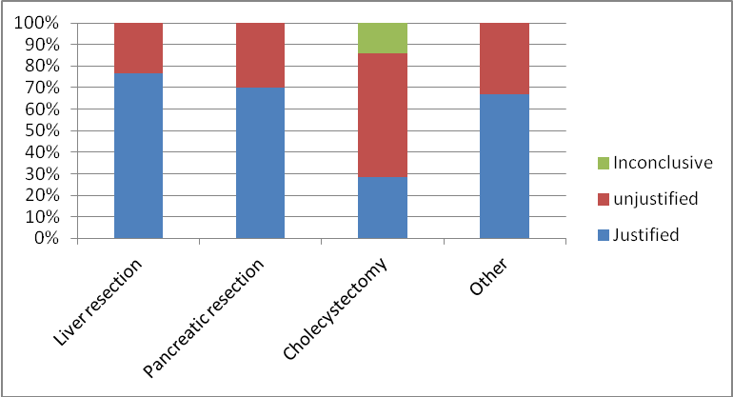

Supplementary file. Fig 3: Justification by procedure

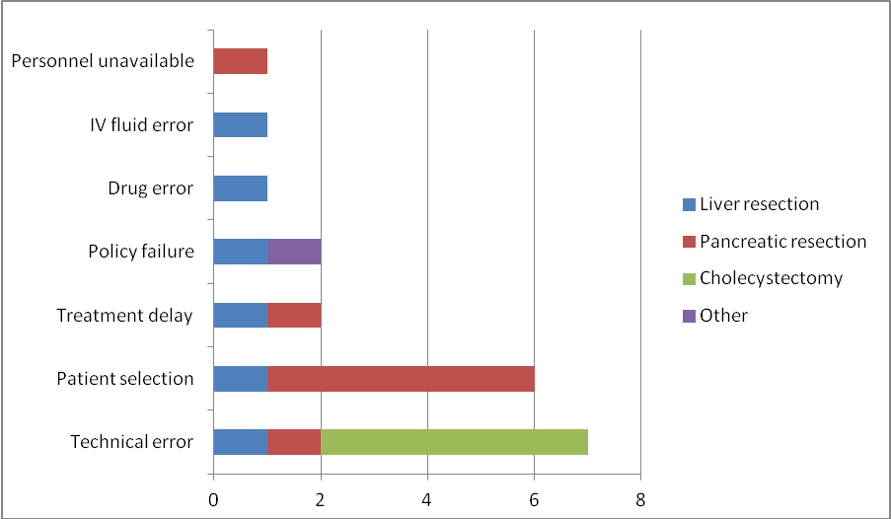

Supplementary file. Fig. 4: Errors identified for each procedure