Supplementary Material 2 : Questionnaire Results

The graphs below show the results of the junior doctor questionnaire that was sent out to all junior doctors involved in the medical take and care of the elderly rota.

Figure 1 shows the proportions of the various grades of junior doctors that completed the survey, ranging from foundation years 1 and 2 to core medical and GP trainees years 1 and 2.
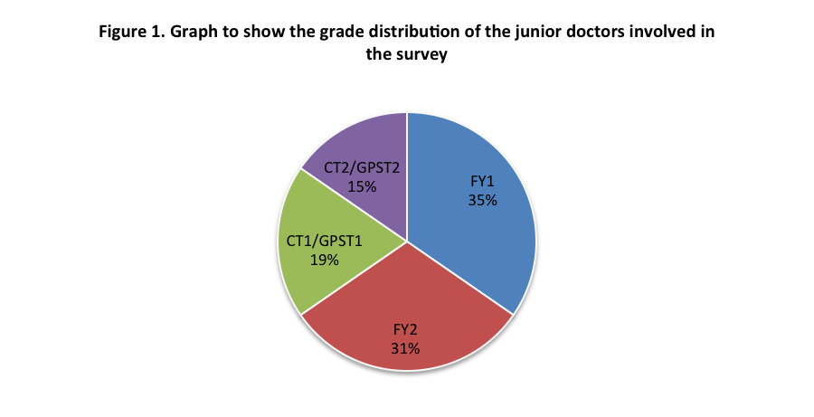

Figure 2 shows what proportion of junior doctors either involved in the medical take or part of the care of the elderly rota had previously had experience in clerking in acute stroke patients.
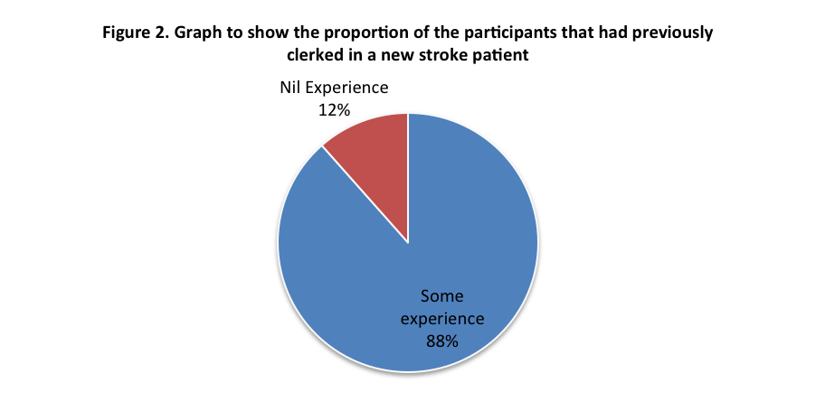

Figure 3 shows the response to the various questions included in the survey to ascertain the particpants confidence in clerking in acute stroke patients, including their awareness of current guidelines and their confidence in instigating an initial management plan.

Figure 3. Graph to show the particpant’s knowledge and confidence in acute stroke management

Figure 4 shows the number of partipants who stated that they routinely instigate an initial management plan in keeping with hospital and national guidelines. This included requesting the initial investigations required for all new stroke admissions.

Figure 4. Graph to show the proportion of participants that routinely request the recommended stroke specific investigations

Figure 5 shows the participants response to the proposed introduction of a stroke specific clerking proforma or check-list, deomnstrating their opinion about whether they felt it would be a valuable tool.
