FIGURE 1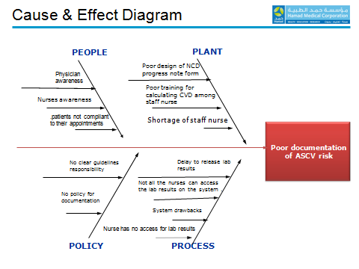
TABLE 1

Figure 2

