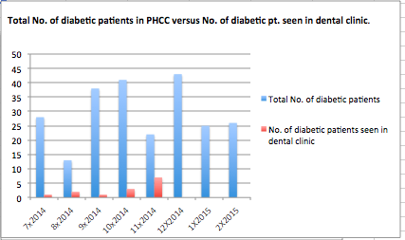
Figure 1: Total No. of diabetic patients versus No. of diabetic patients seen in dental clinic

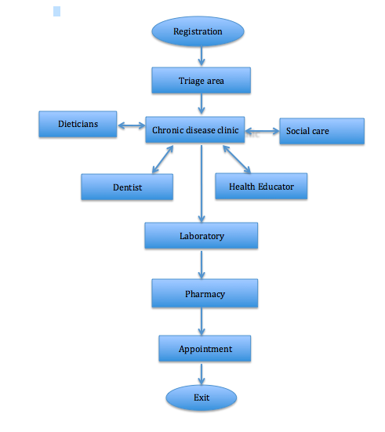
Figure 2: flow chart of diabetic patients in PHCC
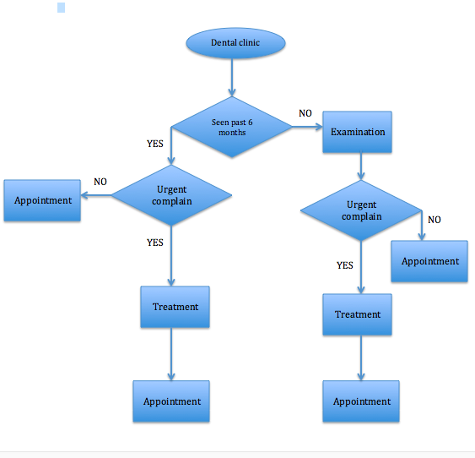
Figure 3: flow chart of diabetic patients in dental clinic

