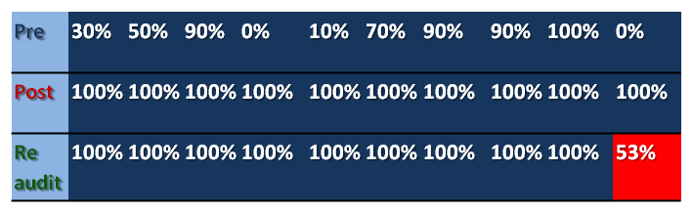
Fig 2. Graph and table to show percentage of discharge letters containing required information prior to, in the month following and in the year following introduction of a discharge proforma.

