Appendix B: Intervention Results Tables & Figures
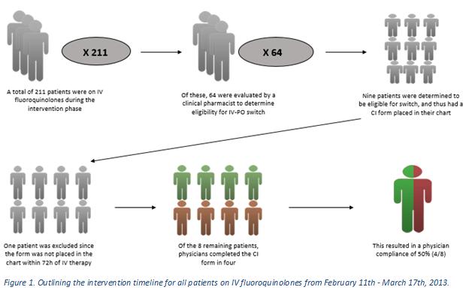

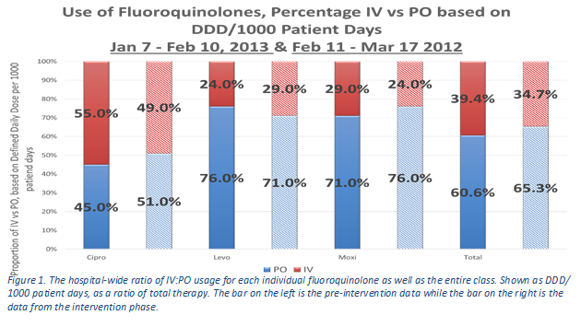

Table 2. Comparison of patient outcome data between the individuals who had the attending physician complete the Clinical Intervention form to those who did not.
 | Physician Compliance | Non Physician Compliance
No. of patients | 4 | 4
Average days IV | 3 | 4.25
Average days PO | 3 | 2.75
Ratio IV:PO | 1:1 | 1.55:1
4+ days on IV abx | 1 | 3

