Figure 1 : An example of a typical handwritten TTO discharge medication prescription given to patient’s at time of discharge.
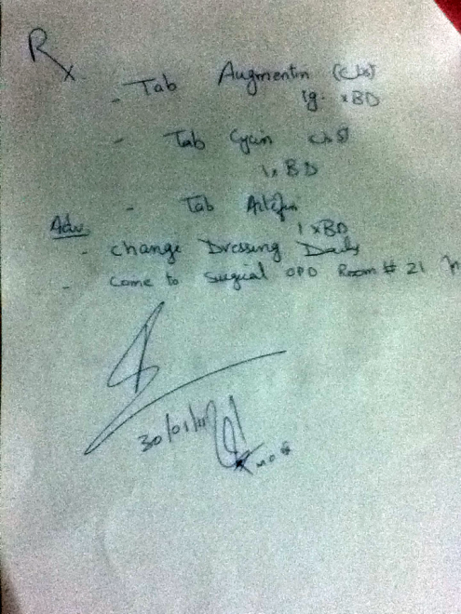
Table 1 : Percentage of patients who could understand their TTO discharge prescription at time of discharge. N = number of patients in each subgroup (100 patients in total)
Patient Subgroup | Adherence
 | N | %
Literate, and received counselling | 24 | 100
Literate, but not counselled | 28 | 93
Illiterate, and received counselling | 26 | 12
Illiterate, but not counselled | 22 | 5
Total patient population, and received counselling | * | 58
Total patient population, and not received counselling | * | 51

Bar chart 1 :

