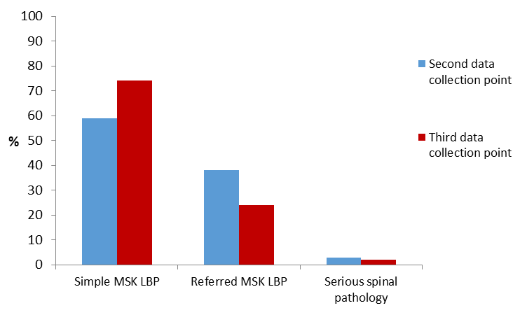
Figure 1: Distribution of MSK LBP types at the second and third data collection points (pre and post implementation) of the EBLBPP (n=200)

Second Data Collection Point  Mean age, SD (min age; max age) | Third Data Collection Point  Mean age, SD (min age; max age)
41 ± 15 (20; 85) | 46 ± 17 (22; 91)

Figure 2: Demographic data between the second and third data (pre and post implementation) collection points

History | 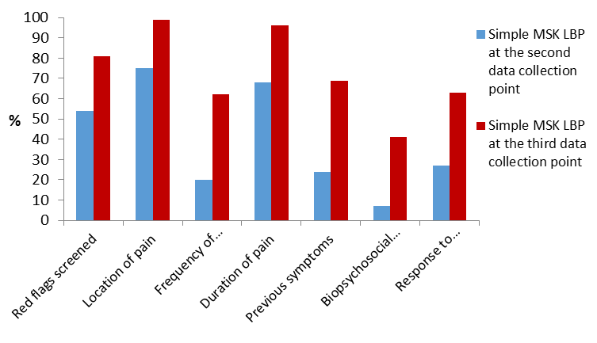 | 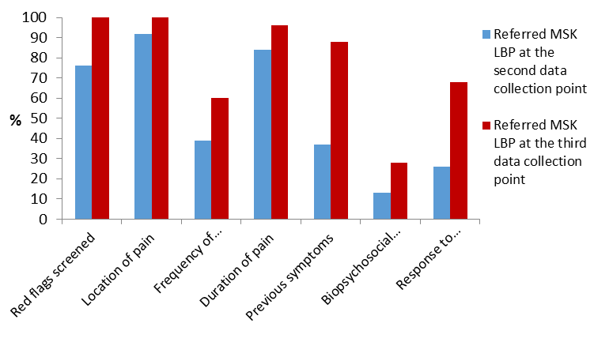 | 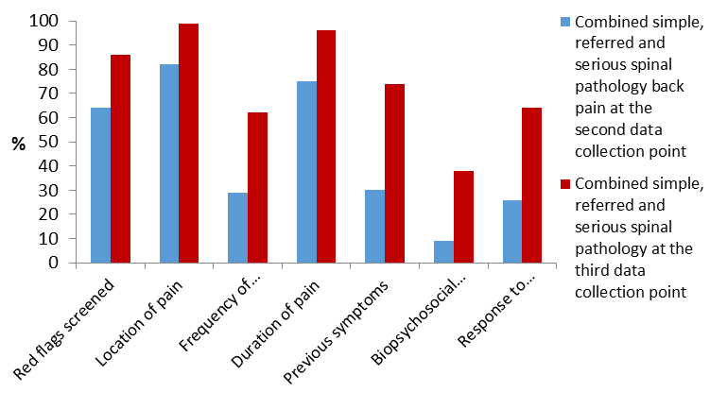
Examination | 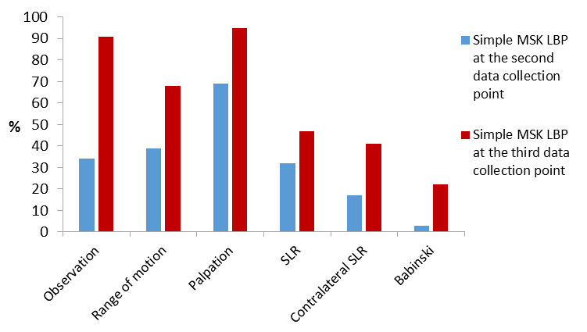 | 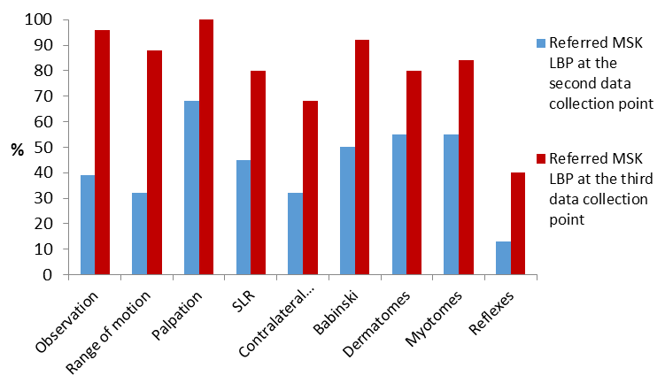 | 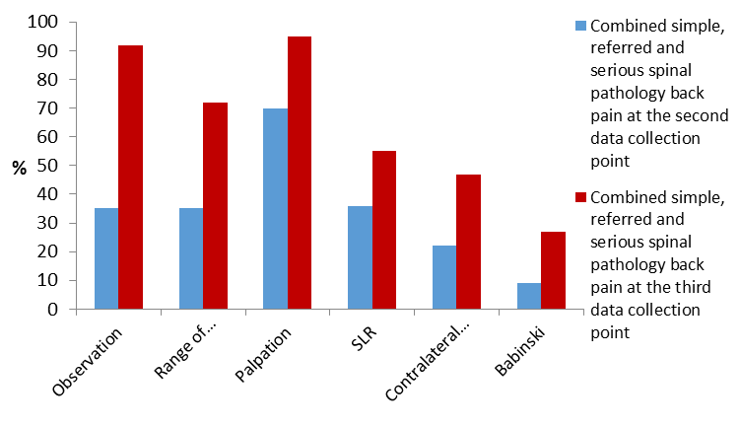
Classification | 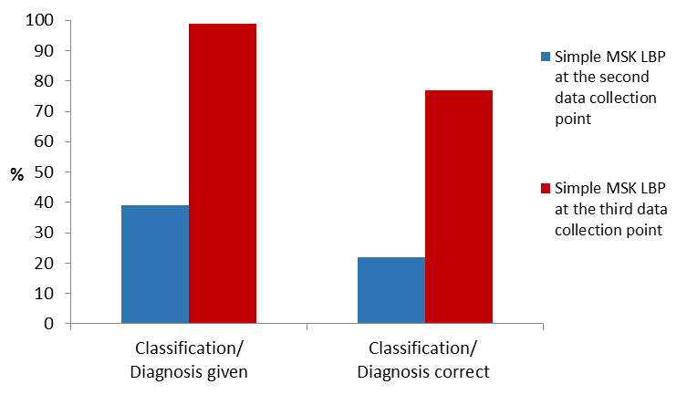 | 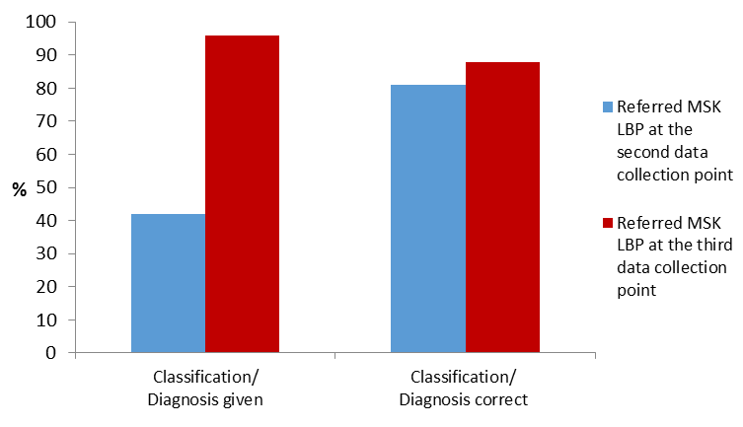 | 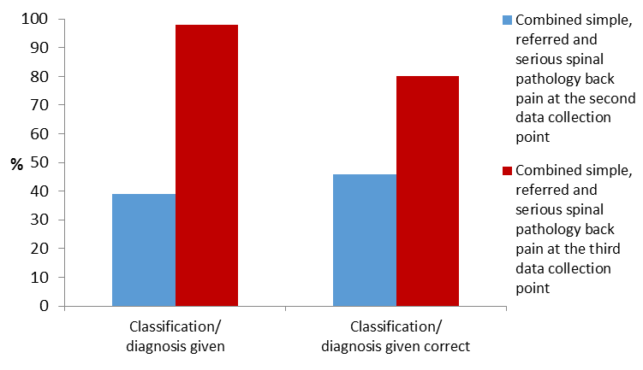
Investigations | 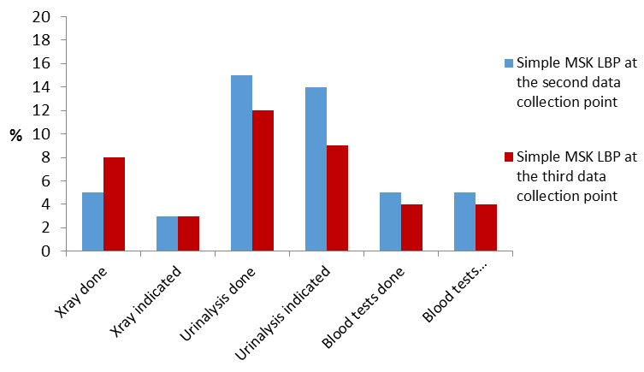 | 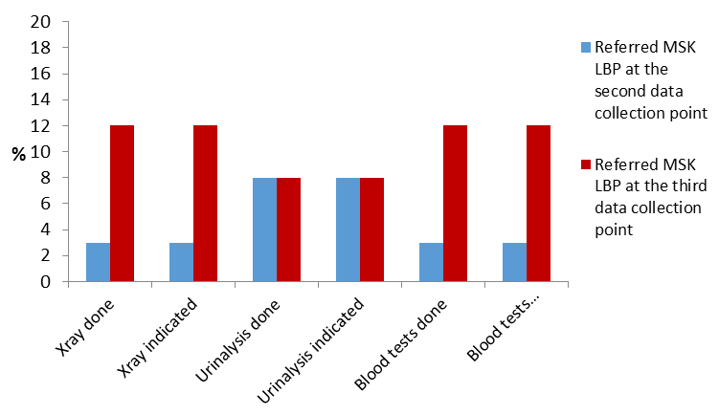 | 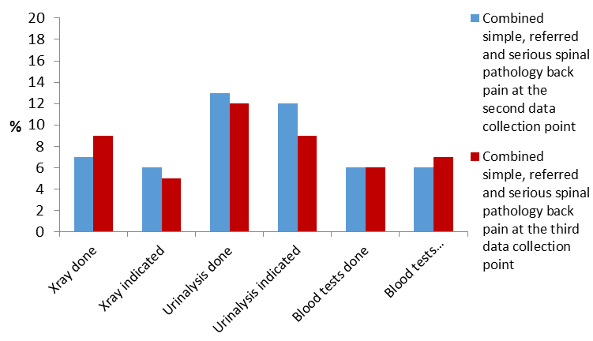
Management | 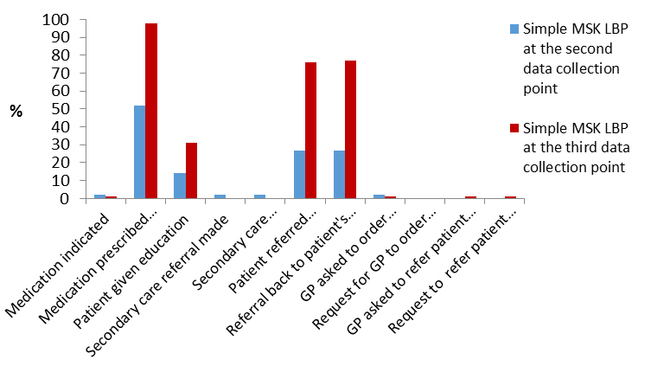 | 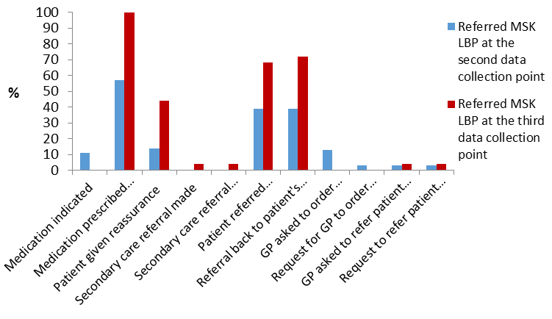 | 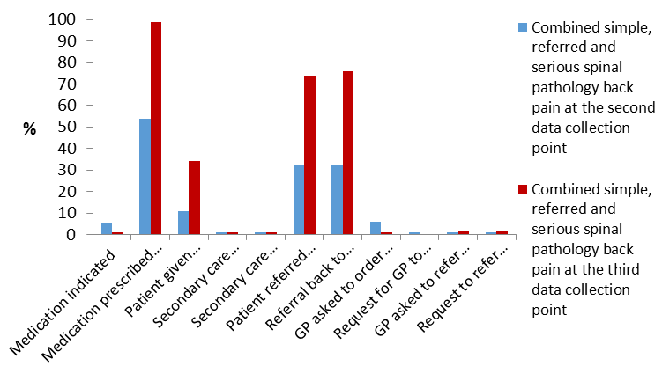

Figure 3: The percentages of success in the areas evaluated at the second and third data collection points (before and after implementation of EBLBPP, staff education and patient education booklet by types of LBP: in simple, referred and combined simple, referred and serious spinal pathology MSK back pain)

 | Simple  (n=133: SDCP=59, TDCP=74)  Difference (95% CI) | Referred  (n=62, SDCP=38, TDCP=24)  Difference (95% CI) | All**  (n=200)  Difference (95% CI)
History
Red flags screened | 27 (11, 42) ^{(††)} | 24 (10, 37) ^{(††)} | 22 (10, 34) ^{(††)}
Location of pain | 24 (13, 35) ^{(†††)} | 8 (-1, 16) | 17 (9, 25) ^{(†††)}
Frequency of symptoms | 41 (26, 56) ^{(†††)} | 21 (-4, 45) | 33 (20, 46)
Duration of pain | 28 (15, 41) ^{(†††)} | 12 (-2, 26) | 21 (12, 30) ^{(†††)}
Previous symptoms | 45 (30, 60) ^{(†††)} | 51 (30, 71) ^{(†††)} | 44 (31, 56) ^{(†††)}
Biopsychosocial factors | 34 (21, 47) ^{(†††)} | 15 (-6, 35) | 29 (18, 40) ^{(†††)}
Response to previous treatment | 35 (19, 51) ^{(†††)} | 42 (19, 65) ^{(††)} | 38 (25, 51) ^{(†††)}
Examination
Observation | 57 (43, 70) ^{(†††)} | 57 (39, 74) ^{(†††)} | 57 (46, 68) ^{(†††)}
Range of motion | 29 (12, 45) ^{(†)} | 56 (37, 76) ^{(†††)} | 37 (24, 50) ^{(†††)}
Palpation | 25 (12, 38) ^{(†††)} | 32 (17, 46) ^{(††)} | 25 (15, 35) ^{(†††)}
SLR | 15 (-1, 32) | 35 (13, 58) ^{(††)} | 19 (5, 33) ^{(†)}
Contralateral SLR | 24 (9, 39) ^{(†)} | 36 (13, 60) ^{(††)} | 25 (13, 38) ^{(†††)}
Dermatomes | - | 42 (23, 61) ^{(††)} | -
Myotomes | - | 25 (2, 47) | -
Reflexes | - | 29 (7, 50) ^{(††)} | -
Babinski | 19 (8, 29) ^{(†)} | 27 (5, 49) ^{(††)} | 18 (8, 29) ^{(†††)}
Classification
Classification/Diagnosis given | 60 (47, 72) ^{(†††)} | 54 (36, 71) ^{(†††)} | 59 (49, 69) ^{(†††)}
Classification/Diagnosis correct | 55 (36, 74) ^{(†††)} | 6 (-17, 30) | 33 (16, 51) ^{(†††)}
Investigations
Xray done | 3 (-5, 11) | 9 (-4, 23) | 2 (-6, 10)
Xray indicated | -1 (-7, 5) | 9 (-4, 23) | -1 (-7, 5)
Urinalysis done | -3 (-15, 9) | -0.01 (-14, 14) | -1 (-10, 8)
Urinalysis indicated | -4 (-15, 7) | -0.01 (-14, 14) | -3 (-11, 5)
Blood tests done | -1 (-8, 6) | 9 (-4, 23) | 0 (-7, 7)
Blood tests indicated | -1 (-8, 6) | 9 (-4, 23) | 1 (-6, 8)
Management
Medication indicated | -0.3 (-5, 4) | -11 (-20, -0.7) | -4 (-9, 1)
Medication prescribed followed analgesic ladder recommendations | 49 (36, 62) ^{(†††)} | 43 (26, 59) ^{(†††)} | 45 (35, 55) ^{(†††)}
Patient given education and reassurance | 18 (4, 31) ^{(†)} | 36 (15, 57) ^{(††)} | 23 (12, 34) ^{(†††)}
Secondary care referral made | -2 (-5, 2) | 4 (-4, 12) | 0 (3, 3)
Secondary care referral indicated | -2 (-5, 2) | 4 (-4, 12) | 0% (-3%, 3%)
Patient referred back to their GP | 49 (34, 64) ^{(†††)} | 29 (5, 53) ^{(†)} | 42 (29, 54) ^{(†††)}
Referral back to patient's GP indicated | 50 (35, 65) ^{(†††)} | 33 (9, 56) ^{(†)} | 44 (31, 56) ^{(†††)}
GP asked to order investigations | -0.3 (-5, 4) | -13 (-24, -2) | -5 (-10, 0)
Request for GP to order investigations indicated | * | -3 (-8, 2) | -1 (-3, 1)
GP asked to refer patient to secondary care | 1 (-1, 4) | 1 (-8, 11) | 1 (-2, 4)
Request to refer patient to secondary care indicated | 1 (-1, 4) | 1 (-8, 11) | 1 (-2, 4)
*: Unable to calculate CI due to no occurrence at either time point due to small numbers
**: includes simple, referred and serious spinal pathology
Statistical significance level: p-value < 0.05(+), p-value < 0.01 (++), p-value <0.001 (+++). Confidence interval obtained using Normal approximation to binomial distribution.
SDCP = Second data collection point
TDCP = Third data collection point

Table 1: Estimates of the difference in proportion in the areas evaluated between the second and third data collection points (pre and post implementation EBLBPP, staff education and patient education leaflet) by types of LBP: in simple, referred and combined simple, referred and serious spinal pathology MSK back pain

