Figure 1. Observation protocol used to evaluate the quality of handovers.
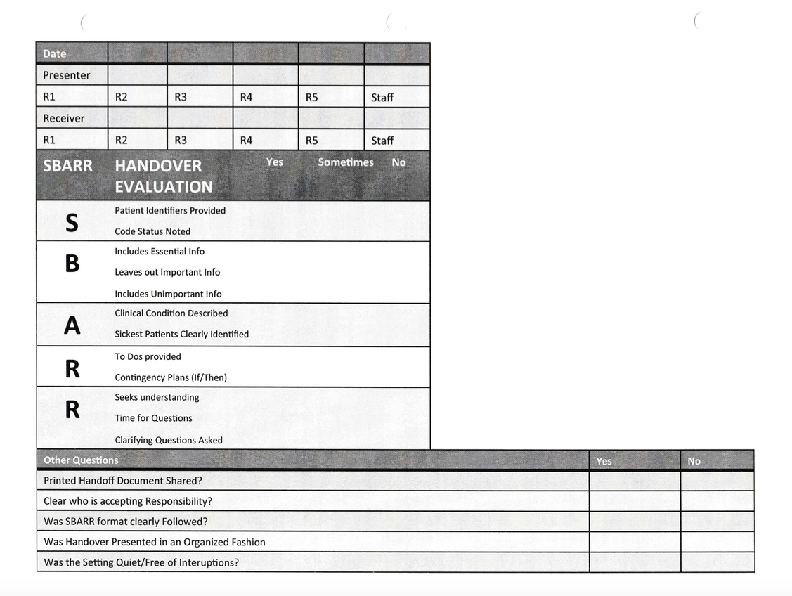
Note: R1 through R5 indicates Resident and her or his year in the program.

