# Supplementary information

**Supplementary Table 1: ICD-10AM codes for sepsis (21)**

|  |
| --- |
| A021 Salmonella septicaemia  A267 Erysipelothrix septicaemia  A327 Listerial septicaemia  A400 Septicaemia due to streptococcus, group A  A401 Septicaemia due to streptococcus, group B  A402 Septicaemia due to streptococcus, group D  A403 Septicaemia due to Streptococcus pneumoniae  A408 Other streptococcal septicaemia  A409 Streptococcal septicaemia unspecified  A410 Septicaemia due to Staphylococcus aureus  A411 Septicaemia due to other specified staphylococcus  A412 Septicaemia due to unspecified staphylococcus  A413 Septicaemia due to Haemophilius influenzae  A414 Septicaemia due to anaerobes  A415 Septicaemia due to other Gram-negative organisms  A4150 Sepsis due to unspecified Gram-negative organisms  A4151 Sepsis due to Escherichia coli  A4152 Sepsis due to Pseudomonas  A4158 Sepsis due to other Gram-negative organisms  A418 Other specified septicaemia  A419 Septicaemia unspecified  A427 Actinomycotic septicaemia  B377 Candidal septicaemia  T8142 Sepsis following a procedure |

**Supplementary Table 2: PMCC resource-use group specifications**

|  |  |
| --- | --- |
| **Resource-use Groups** | **Inclusions** |
| *Allied* | All disciplines including clinical psychology and interpreters |
| *ICU* | Costs of medical, nursing, administrative and other staff in ICU, and supplies used in ICU. |
| *Imaging* | Costs of medical, nursing and administrative staff and supplies involved in providing inpatient imaging services. |
| *Medical* | Costs of all medical non-surgical staff, and supplies used in all medical non-surgical cost centres. |
| *Nursing* | Costs of nurses, other ward staff and supplies used in all nursing ward cost centres. |
| *Outside hospital care* | Costs relating to Hospital in the Home and Home and Community Care (HACC). |
| *Pathology* | Costs of medical, nursing and administrative staff and supplies involved in providing inpatient pathology services. |
| *Pharmacy* | Costs of medical, nursing and administrative staff and supplies involved in providing inpatient pharmacy services (both non-PBS and PBS drugs). |
| *Tests requiring operating room(OR)* | Costs involving tests such as cardio, radiotherapy that would require the use of an OR. |
| *Surgical* | Costs of all medical surgical staff, and supplies used in all medical surgical cost centres, costs of prostheses and cost of theatre and day surgery staff, supplies used in theatre. Also includes robotics and anaesthetists. |

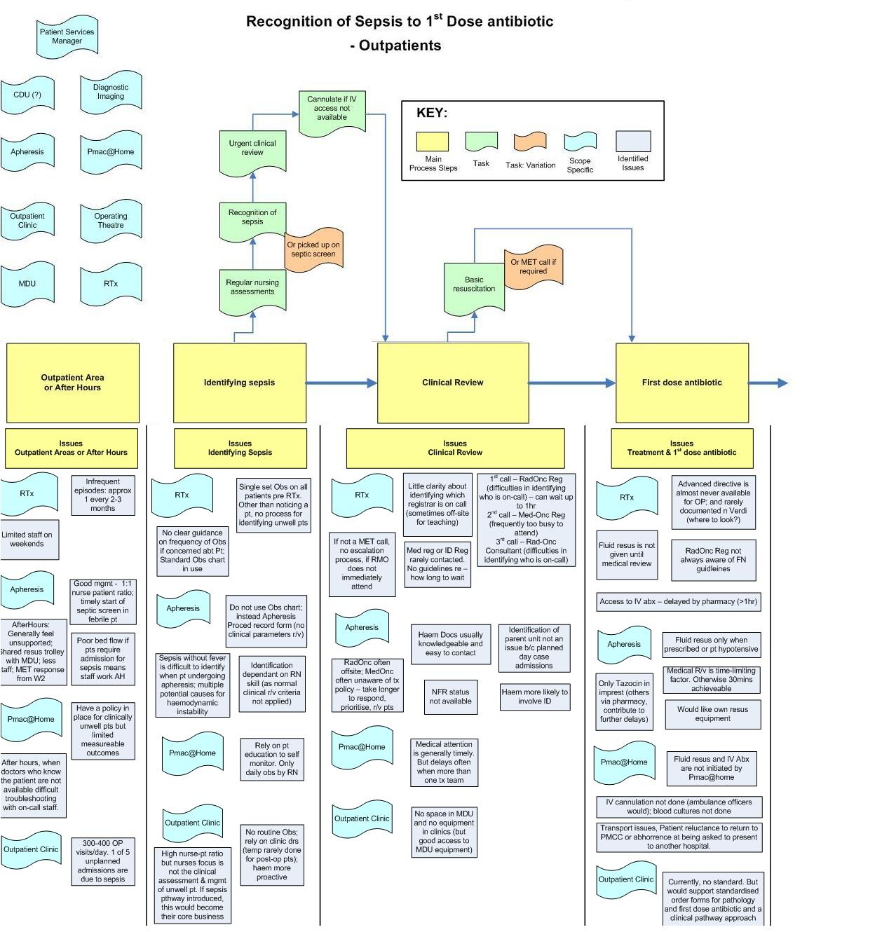

**Supplementary Figure 1: Process map for the management of sepsis in ambulatory areas**

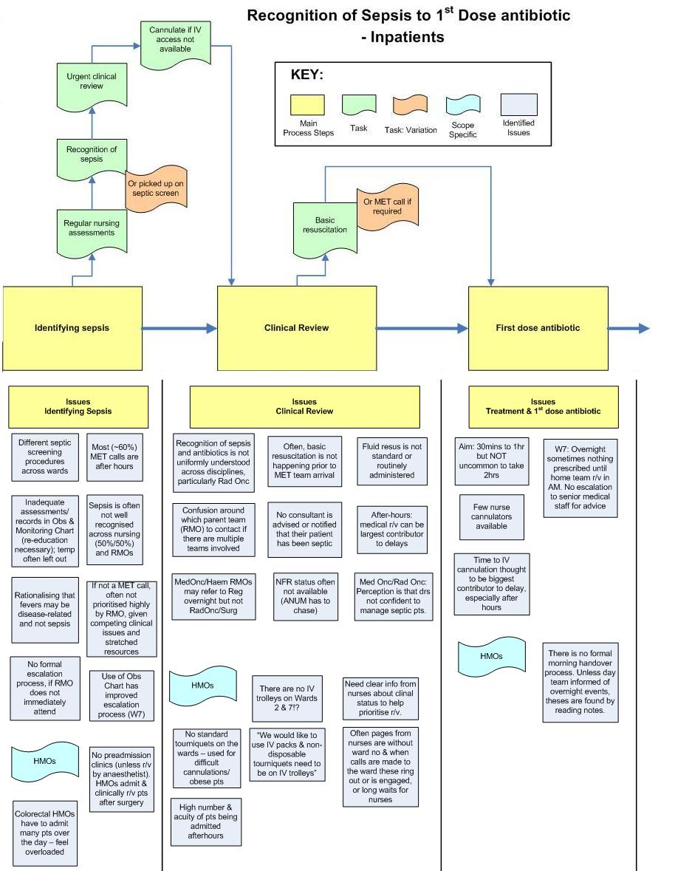

**Supplementary Figure 2: Processing mapping for management of sepsis for inpatients**









**Supplementary figure 3: Sepsis pathway developed at the Peter MacCallum Cancer – Version 1, 2013**

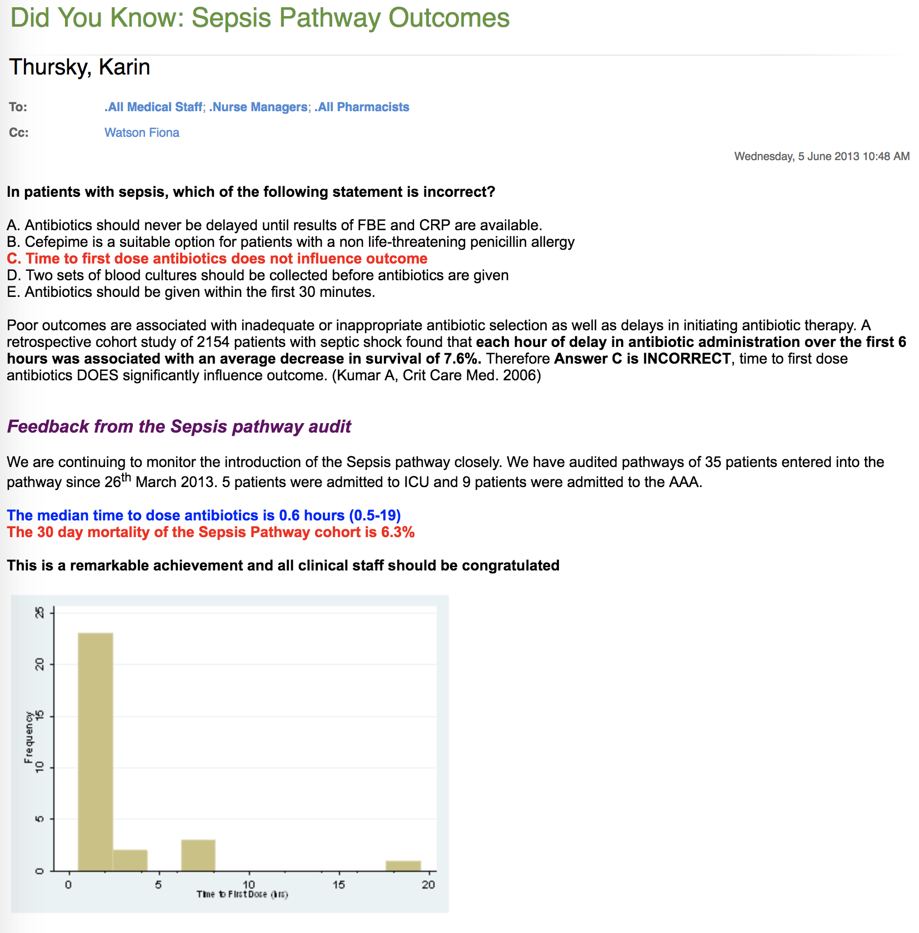

Figure 2: Example of email feedback to clinical staff