Additional File 4: NHS Highland NSAIDs Safety Information Card
Front:
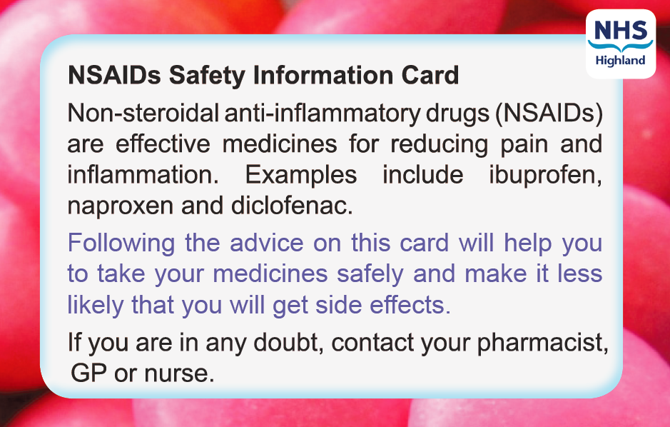
Reverse:
