Supplement

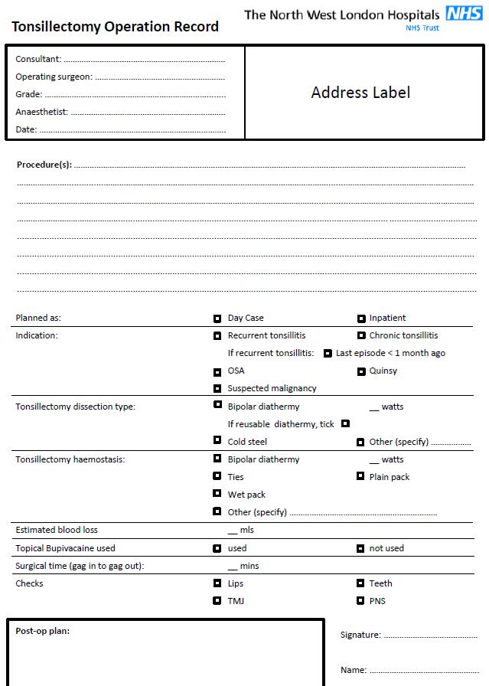
Supplemental Figure 1 The paper proforma (based on [11]).

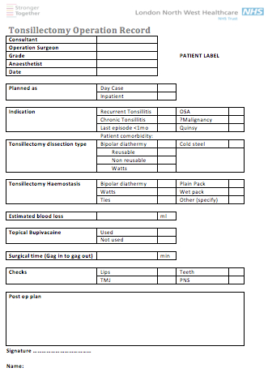
Supplementary Figure 2. The electronic proforma.

