Results

1) Lewisham (n=9)

Comments from initial consultation:

“Perhaps you can standardise the form of the handover to include diagnosis, ECG, physical and blood status and then the outstanding tasks.”
“I think it would be useful to include the mental health act status, when the tribunal is (if due), if there is a report done. Also, perhaps community team status -i.e. referred, needs referral etc.”
“I think it's a good idea to keep it brief so you know what issues need to be addressed before you have the chance to go through the rest of the entries on the system.”
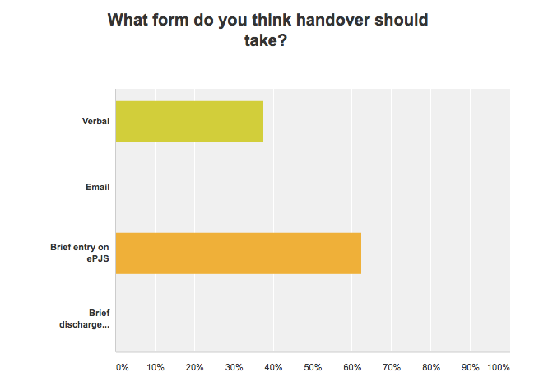

Before Intervention: After Intervention:

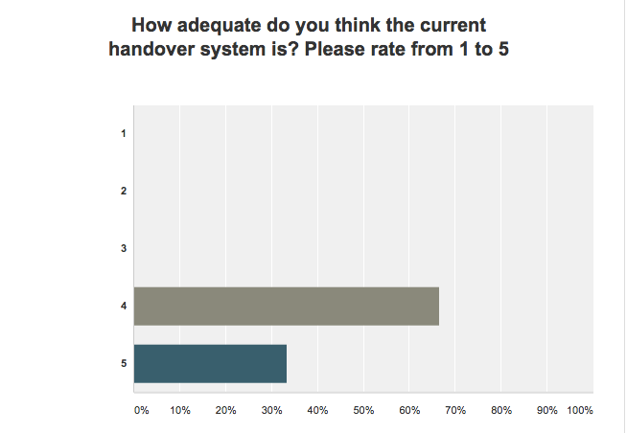
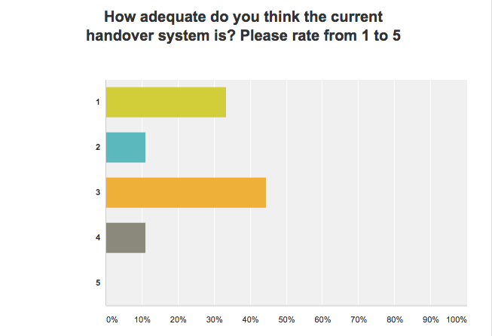

Before Intervention: After Intervention:

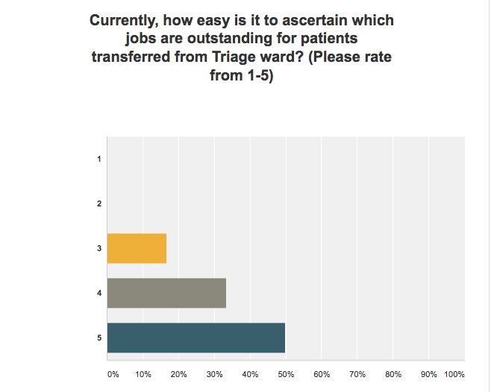
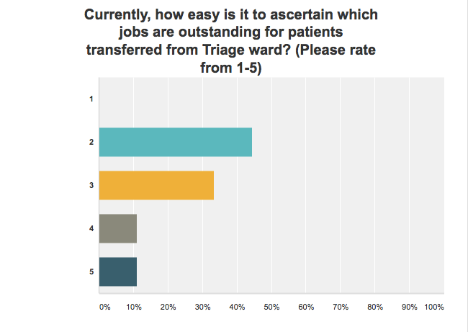

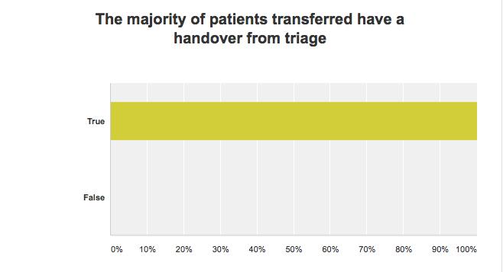

2) Lambeth (n=6)

Comments following initial consultation:

“Especially outstanding ECGs can be hard to trace, as they seldom make their way onto scanned correspondence!”

“Brief entry or on discharge note - not both as would be too much work. Excellent project Mark!”

“I think electronic handover enough except in case of complex/unusual patients...summary of outstanding jobs on EPJ would generally be helpful - although this can usually easily be managed by scanning through the last weeks entries...verbal handover useful occasionally for complex patients Email is too high risk, as may not reach designated individual(s)”

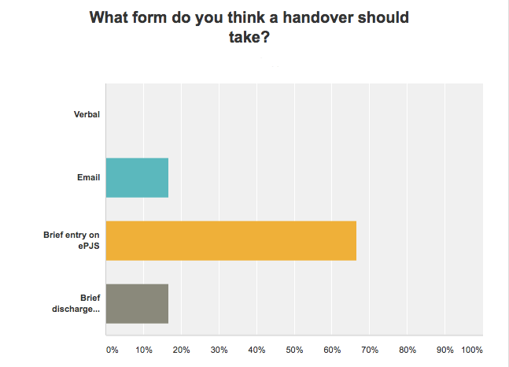

Before Intervention: After Intervention:
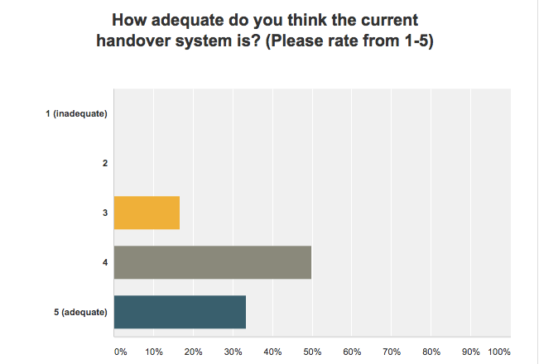
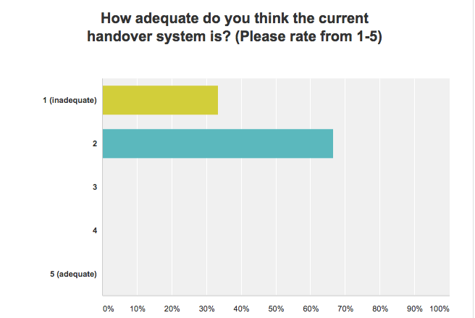

Before Intervention: After Intervention:

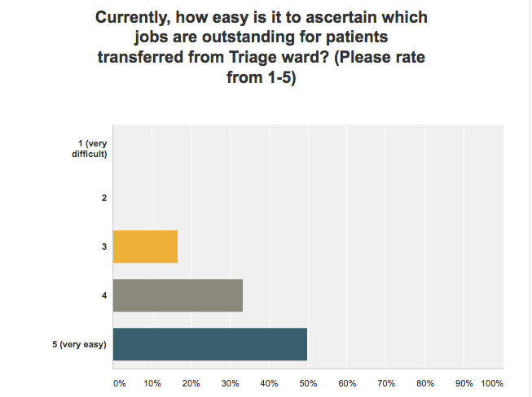
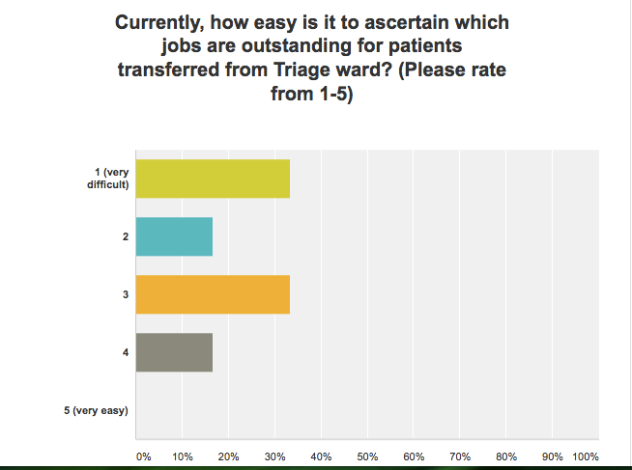

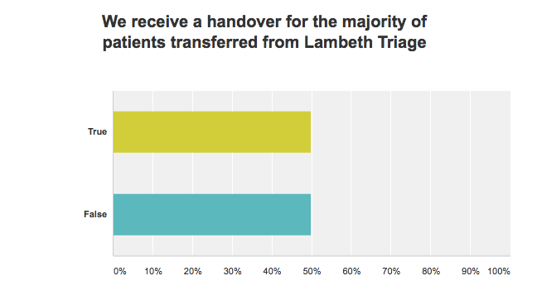

3) Croydon (n=3)

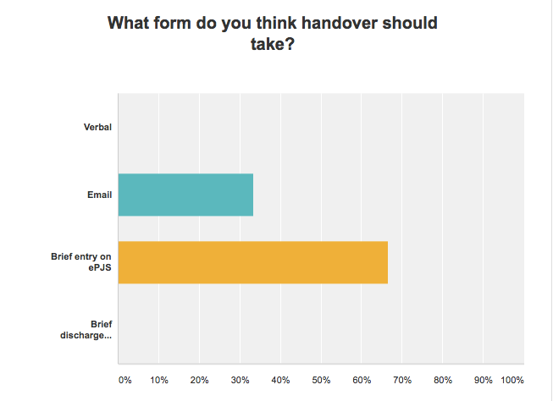

Before Intervention: After Intervention:

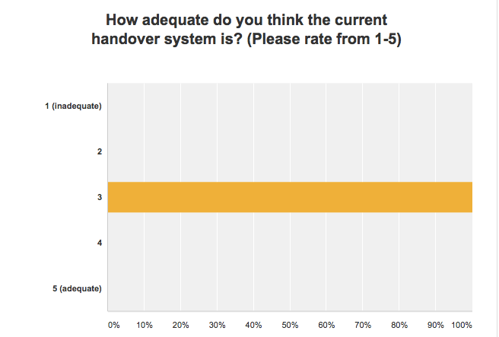
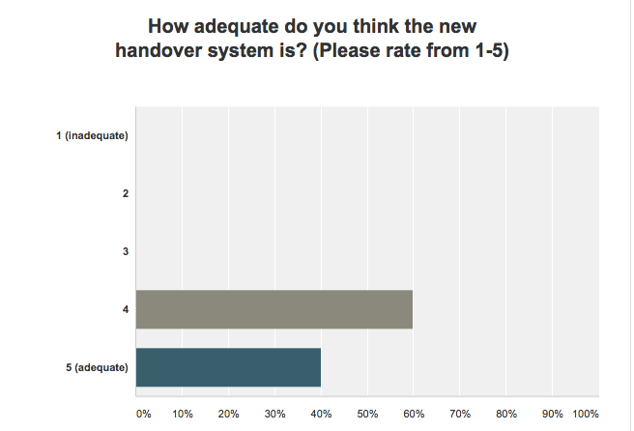

Before Intervention: After Intervention:
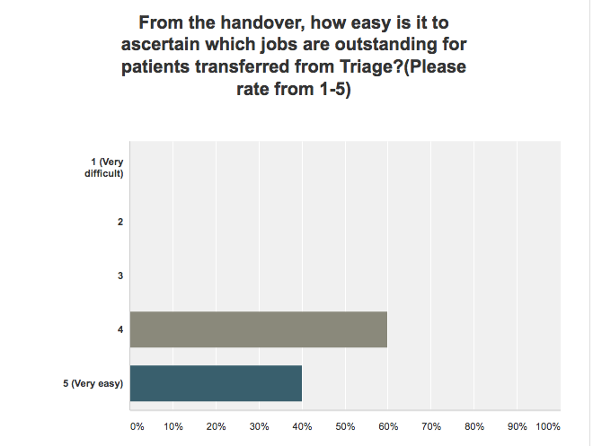
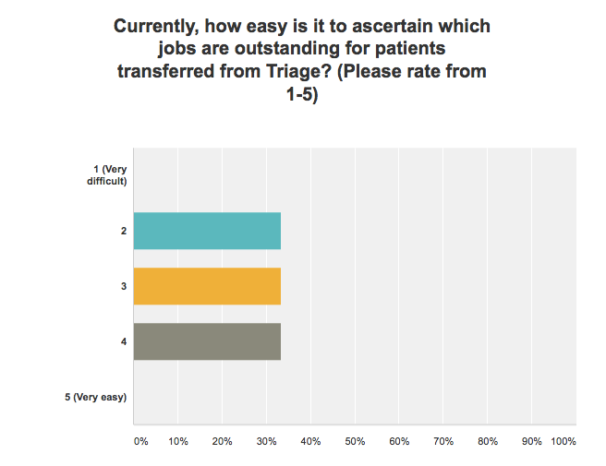

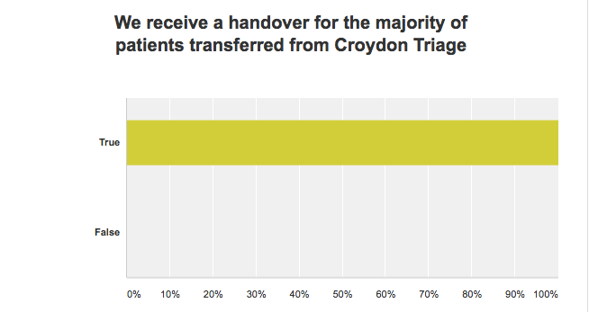

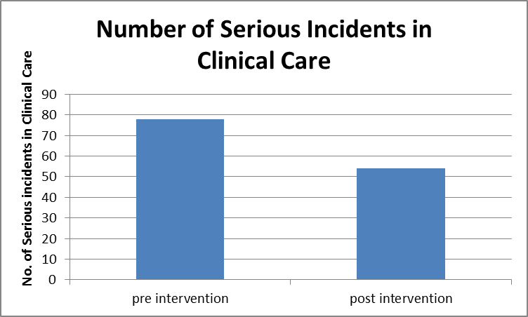

Post intervention SI data (01/05/16- 31/10/16)
TYPE OF INCIDENT | A - Death | B - Severe | C - Moderate | D - Low | E - No Adverse Outcome | Total
Violence/Aggression/Assault | 0 | 1 | 35 | 136 | 91 | 263
AWOL/Abscond/Failed To Return | 0 | 0 | 1 | 59 | 12 | 72
Clinical Care (Inc.Substance Misuse/Pressure Ulcer/Wound) | 0 | 1 | 7 | 21 | 25 | 54
Medication | 0 | 0 | 6 | 5 | 6 | 17
Self-Harm | 0 | 0 | 4 | 9 | 4 | 17
Death | 5 | 0 | 0 | 0 | 0 | 5
Patient Accidents/Health & Safety/Fire | 0 | 0 | 1 | 15 | 13 | 29
Staff Accidents/Health & Safety/Fire | 0 | 0 | 0 | 4 | 2 | 6
Security | 0 | 0 | 6 | 13 | 10 | 29
Confidentiality/IT/Health Records | 0 | 0 | 2 | 2 | 1 | 5
MHA Breach | 0 | 0 | 2 | 2 | 5 | 9
Staff Issues | 0 | 1 | 1 | 16 | 7 | 25
Total | 5 | 3 | 65 | 282 | 176 | 531

