PDSA Cycle 1

Aim: what are you trying to accomplish?
Decreased the number of unnecessary βhCG tests done through educating doctors, nurses and healthcare assistants about current guidelines on serial βhCG management.
Plan: what will your test be?
Education sessions with doctors, nurses and healthcare assistants in both formal and informal contexts, to include improving understanding of current NICE guidelines and exploring current barriers to best practice.
It will be measured by how many unnecessary βhCG tests are done as part of a serial βhCG management plan.

Prediction: what do you think will happen as a result of your test?
The number of unnecessary βhCG tests will decrease as doctors feel more justified in discharging patients if they meet NICE criteria to do so. It is also hoped that nursing staff and healthcare assistants may feel more empowered to question the decision making process if doctors make a different management decision.
Do: what happened when you carried out your test?
The number of unnecessary βhCG dropped.
Study: how did the results of your test compare with predictions?
They were consistent.

Act: how will you change your previous test in light of what you have learned?
Implement a more sustainable change so the change is continued despite staff rotation, without relying solely on repeating education sessions.
PDSA Cycle 2

Aim: what are you trying to accomplish?
To create a sustainable intervention to reduce unnecessary βhCG tests, through education of staff on current guidelines.

Plan: what will your test be?
Addition of “50% off cards” to existing front-sheet on the notes of patients who are currently having serialβhCG management.
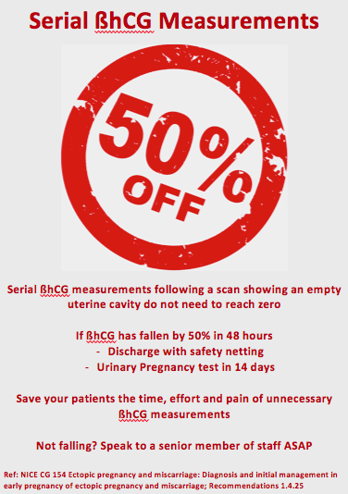

Prediction: what do you think will happen as a result of your test?
The number of unnecessary serial βhCG will continue at the level seen after the education sessions
Do: what happened when you carried out your test?
The number of unnecessary serial βhCG tests done did not decrease further than after PDSA cycle 1, but continued at that level.
Study: how did the results of your test compare with predictions?
It was consistent

Act: how will you change your previous test in light of what you have learned?
These cards have now been included in routine practice for all patients, in conjunction with the front sheet.

