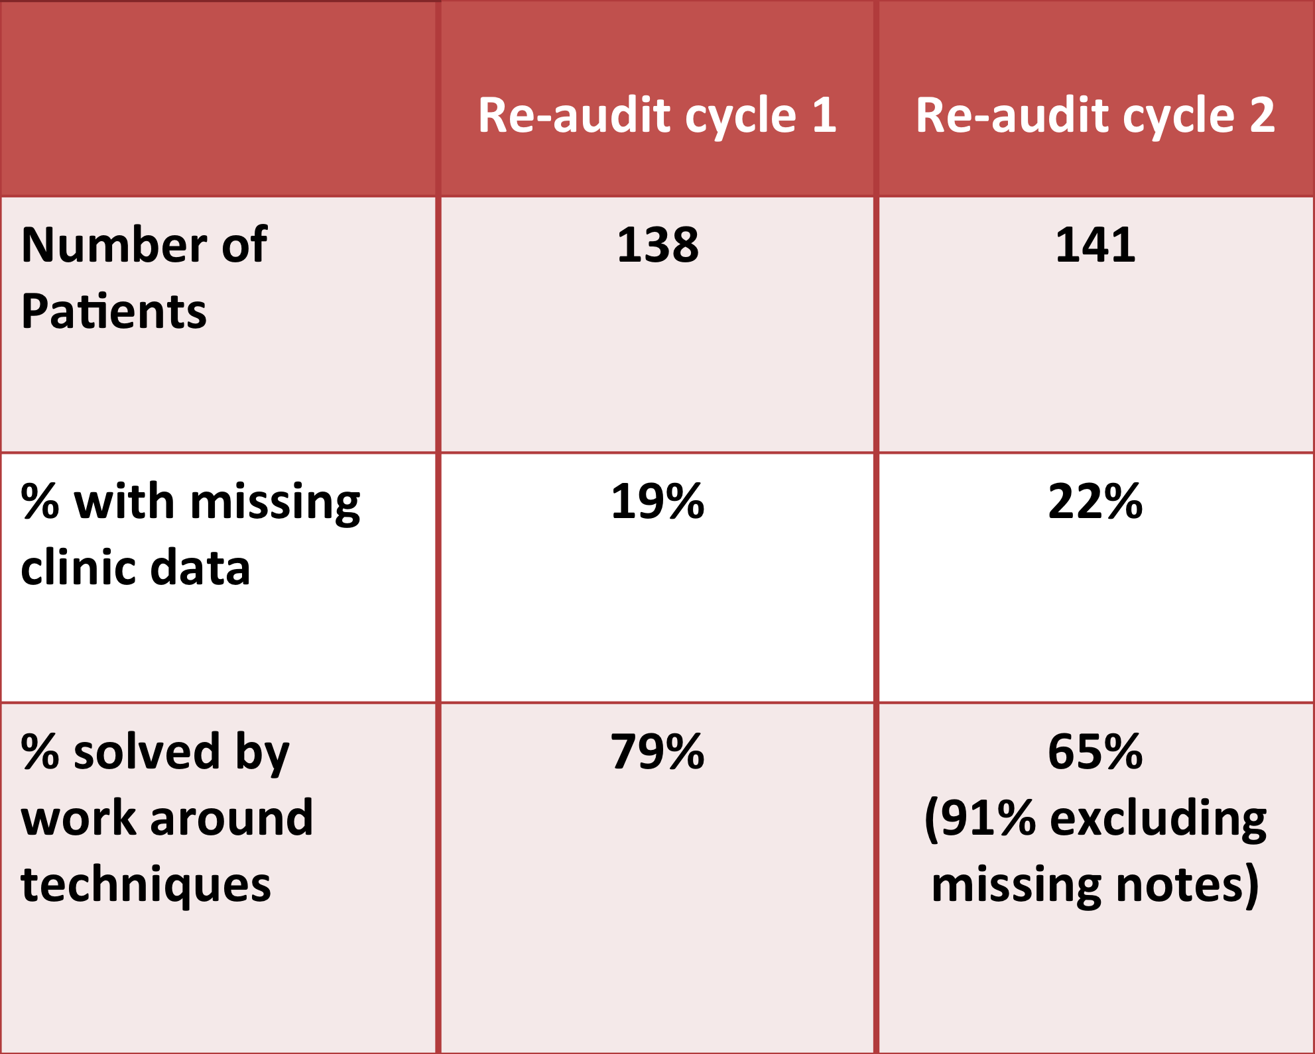

**Figure 3: A table to show results of implicating a work around. Measurement of Improvement.**