2014 | Jan | Feb | Mar | Apr | May | Jun | Total | Monthly average
Admin | 7 | 6 | 6 | 2 | 4 | 8 | 33 | 5.5
Nursing | 27 | 35 | 35 | 19 | 27 | 20 | 163 | 27
AHP | 4 | 1 | 4 | 2 | 2 | 2 | 15 | 2.5
Medical | 3 | 5 | 1 | 3 | 3 | 2 | 17 | 3
Totals: | 41 | 45 | 41 | 26 | 36 | 32 | 228
Table 1: Datix reporting rates at WGH 2014

Fig 1 Doctor’s job to report?

Fig 2 Hazards noticed but not reported

Fig 3 Fear of getting into trouble

Fig 4 Speed of filling in datix

Fig 4 Ease of filling in datix

Fig 5 Affect of anonymity on reporting

Fig 6 Importance of follow up

Fig 7 Concern re managers
Fig 8. Reporting project adverising poster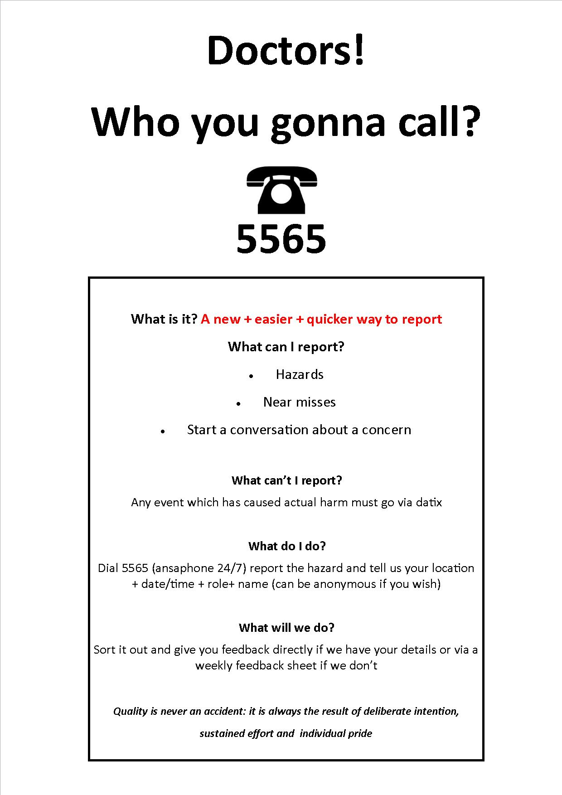

Fig 9 Driver diagram

